**Text Recognition in License Plate Using OpenCV (Python)**

1. **Goal:**

* To extract the license plate number from the image by performing various image processing techniques.

1. **Flow:**
2. **Input Image:**

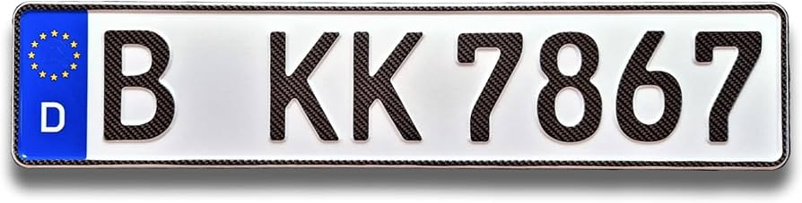

1. **Final Dilated Image:**

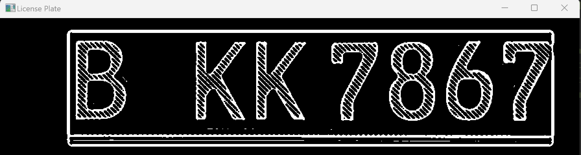

1. **Extracted Text Output:**

